“Fuller in Phila” Symposium Program

Monday, October 14th, 2013, 4-8pm, at the ExCITe Center

4:00 – 4:10 Introduction by Mimi Sheller, Director, Center for Mobilities Research & Policy, and Youngmoo Kim Director of the ExCITe Center, Drexel University

4:10 – 4:55
Screening the Cold War
Eva Díaz

This talk will take up Bucky Fuller’s argument that architecture could be a key element in understanding and representing the management of networked resources, and that the dome in particular could be a networked building—a site connected to real-time information feeds updated in various media. I explore the idea of the geodesic dome as evocative of a networked Earth – or of networks in orbit around Earth – in order to understand why the dome acquired its special purchase in the post-war period, and why the subject’s processing of complex media in such a space was deemed a crucial aesthetic confrontation with the psychic and physical demands of the Cold War. This talk will specifically focus on three film projects involving projection within domes, by Charles and Ray Eames, Stan Vanderbeek, and Stanley Kubrick with Douglas Trumbull.

Eva Díaz is Assistant Professor of Contemporary Art at Pratt Institute in New York. Her book The Experimenters: Chance and Design at Black Mountain College will soon released by University of Chicago Press, coinciding with the 80th anniversary of the founding of the College. Her writing has appeared in magazines and journals such as The Art Bulletin, Art Journal, Art in America, Cabinet, Frieze, Grey Room, October, and Tate Etc., and she is a regular contributor to Artforum. She is currently working on a book about the legacy of Buckminster Fuller’s work titled The Fuller Effect: The Critique of Total Design in Postwar Art.

5:00 – 5:45
Fuller in Phila - The Last Decade
Tim Wessels

In late 1972 Buckminster Fuller was invited to become the first World Fellow in Residence at the University City Science Center. Sponsorship was provided by a consortium consisting of the University City Science Center, the University of Pennsylvania, Swarthmore College, Haverford College and Bryn Mawr College. Fuller’s tenure in Philadelphia (1973 - 1983) made him more accessible to his friends and associates. It was during this decade that Bucky enjoyed a continued revival of interest in his work that began in the late 1960s with the publication of the Whole Earth Catalog. This presentation is a personal recollection of Fuller’s life and work as it contributed to the richness and productivity of his final decade on planet Earth.

Tim Wessels was born in Cincinnati, Ohio, and moved to Philadelphia in May of 1973 to work as a staff member in Bucky’s Philadelphia office. He managed part of Fuller’s archives, assisted in the fabrication and installation of museum exhibits, fulfilled orders for Bucky’s books and maps and provided personal service to Bucky when he was in town. At the end of 1979, Tim relocated to New Hampshire and worked for several solar energy research and pollution control businesses before discovering the joy of micro-computers. Having installed and supported hundreds of local computer networks throughout New England, he currently consults on the use of cloud computing services and plans to create a regional cloud storage service in New England.

5:50 – 6:30
“Emergence by Emergency” and Sustainability Today
Mimi Sheller

In his 1981 book Critical Path, R. Buckminster Fuller offers one of the truly global histories of the temporal evolution of human and planetary history, in which he crucially links the modern era to the use of metals and the formation of what he calls a “metals cartels capitalism”. This talk will explore the contemporary significance of Fuller’s critique of “World War Gaming” in which there is a continuing investment in the technologies of lightness and speed, which he referred to as “ephemeralization” and “acceleration”. He hoped that the accelerating temporalities of technological turnover and ever-improving metal-alloy capabilities that support military superiority might one day be turned to the protection and improvement of humanity. His alternative was the World Game, which was played in the 1980s in the old gymnasium at Drexel University. The “objective of the game would be to explore ways to make it possible for anybody and everybody in the human family to enjoy the total Earth without any human interfering with any other human and without any human gaining advantage at the expense of another” (Fuller 1981: 169). I explore the implications of his idea of one “accounting system” for the “family of humans aboard Spaceship Earth” (Fuller 1981: 202) for sustainability today.

Mimi Sheller is Professor of Sociology and Director of the Center for Mobilities Research and Policy at Drexel University in Philadelphia. She has published extensively in the fields of Caribbean Studies and Mobilities research, and recently completed a series of articles and a book on the cultural history of aluminum in the making of light modernity, inpsired in part by the work of Bucky Fuller. She is the author of Democracy After Slavery (Macmillan, 2000); Consuming the Caribbean (Routledge, 2003); Citizenship from Below: Erotic Agency and Caribbean Freedom (Duke University Press, 2012); and Aluminum Dreams: The Making of Light Modernity (MIT Press, 2014). She is founding co-editor of the journal Mobilities, associate editor of Transfers, and co-editor with John Urry of Mobile Technologies of the City (Routledge, 2006) and Tourism Mobilities (Routledge, 2004).

6:30 – 7:00 Refreshments break

7:00 – 8:00 A Workshop with Joseph D. Clinton

The Dance of a “Jitterbug” triangle tessellation

While in Forest Hills, New York Buckminster Fuller spent two years researching his ideas on Energetic-Synergetic Geometry. The following year during the summer of 1948 while teaching at Black Mountain College he discovered the ‘Jitterbug’ transformation. It was a Eureka moment and marked the beginning of most of his unique discoveries.

The workshop will give each participant the opportunity to make and take a model of one of the developments emerging from Fuller’s original thought. The model will illustrate the physical realities of applying the synergetic geometry principles of rotation and translation transformations of a linkage of triangles from one symmetry form to another. Each participant will also receive a CD containing animated films and reference materials that will illustrate the theoretical application of the mathematical abstractions.

The model:
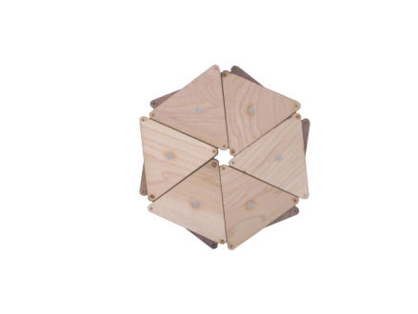

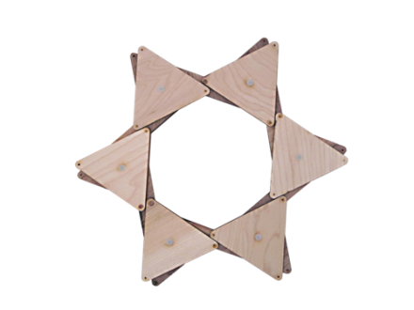

Joseph D. Clinton is globally recognized for his association with R. Buckminster Fuller. This relationship began during his graduate studies at Southern Illinois University. Their collaboration resulted in a number of computer models for designing geodesic and kinetic structures. They have become the classic design basics for most modern day geodesic structures. Joseph has continued to investigate kinetic systems and minimal surface structures and applies them to design problems.

He is President/CEO of PolyModular, Ltd., and Clinton International Design Consultants. He was the coordinator of Design Technology programs at Kean University for 14 years, Director of Engineering/Design Scientist with Spitz Inc. where he was responsible for the engineering of spherical Planetarium and Space Theater screens and Aerospace flight simulation equipment. He was co-founder of 3-D Structures, Inc., a leading design and manufacturer of Aerospace flight simulation equipment. He is retired from a world leader in Visual Displays, a British firm, SEOS, Ltd., as a Design Scientist.

He served on the Board of the Buckminster Fuller Institute, the Advisory Board of RBF Dome, and one of the founders and Past President of Synergetics Collaborative a not for profit association of Synergeticists. He has published in leading journals and given workshops on Synergetics & Design Science, holds several patents and is an internationally recognized Design Scientist.

